Date…………………………

Name…………………………………………………………………………
DOB ………………………………………………………………………….-
We are updating our records – if you are 18 or over can you please answer the following questions:
Are you are carer or do you care for someone? Yes/No
Do you smoke Yes / No
If yes how many per day? ………………………………
Are you an ex-smoker? Yes / No
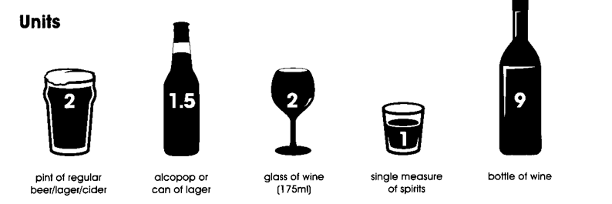
How many units of alcohol do you drink each week? ………………………………

Physical Activity
How many days per week do you engage in physical activity (e.g. brisk walk, gardening, dancing, cycling etc.)? ……………………………………
On those days, how many minutes on average do you engage in physical activity? …………………………………………….
All of our patients now have a named GP – Please ask at reception for more details

